Internship

**TestReport**

**Steppermotor water resolution**

**Student:** Casper R. Tak

**Studentnumber:** 657313

**Client**: Rudie van den Heuvel

**Coach:** Jeroen Veen

**High School:** HAN Arnhem

**Education:** Embedded Systems Engineering

**Date:** 29-11-2022

Inhoud

Objective 3

Test Setup 3

Test Results 4

Conclusions 5

Further actions 5

# Objective

The component that will be tested in this test report will be the stepper motor resolution. This component is responsible for moving fluids from point a to point b.

# Research

Inner volume of the pipe used is calculated using:

**volume = π × (d2/4) × h**

d = 1mm, h = 670mm

the volume will be: π × (12/4) × 670 = 526.22 cu/mm (cubical mm)

or a total of 526 microliters will be in the clear part of the tube.

Now it is important to see how much degrees the motor has to rotate to move the water 1cm in the clear tube

**volume = π × (d2/4) × h**

d = 1mm, h = 10mm

the volume moved will be: π × (12/4) × 10 = 7.85 cu/mm (cubical mm)

so 7.85 microliters is moved.

# Test Setup

* Testing equipment:
  + Hardware:
    - Zaleae Logic 16
    - TMC2209 stepper driver
    - BJ-RZ1030-4 stepper motor (12V)
  + Software:
    - VSC
    - SSH connection to RPI
    - Logic 2.3.45
* Setup hardware/software

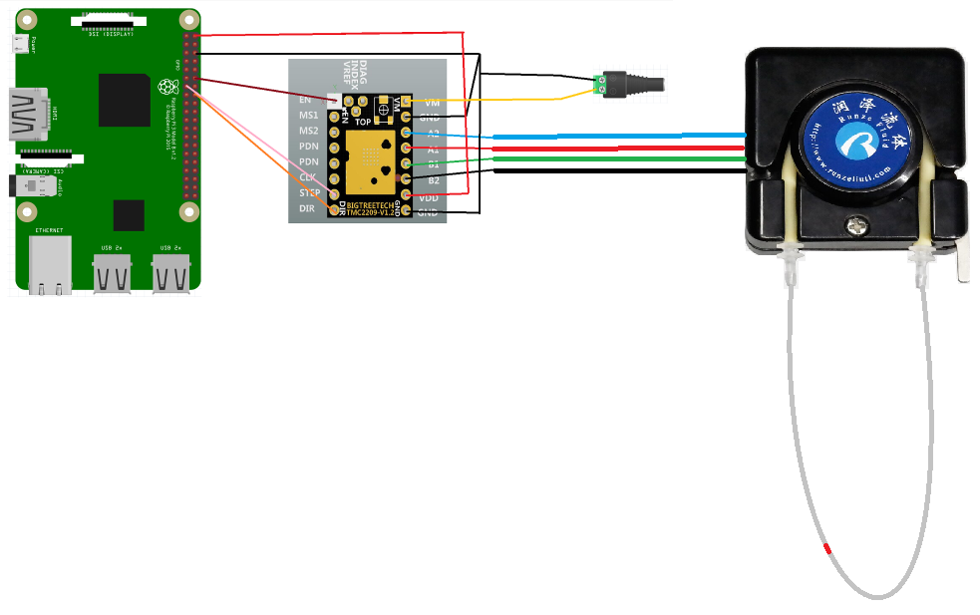

# Test Results

|  |  |  |  |  |  |  |
| --- | --- | --- | --- | --- | --- | --- |
| Test | Test passed if: | Observations | Test passed | Test Failed | Pictures | Notes |
| T1.0 |  |  |  |  |  |  |
| T1.1 |  |  |  |  |  |  |
| T2.0 |  |  |  |  |  |  |
| T2.1 |  |  |  |  |  |  |
| T2.2 |  |  |  |  |  |  |

# Conclusions

# Further actions